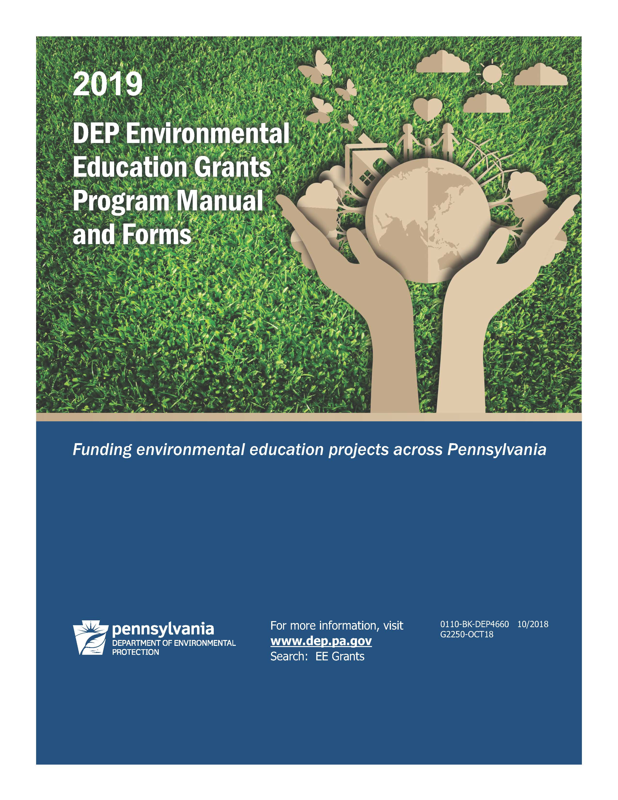

|  |
| --- |
| What’s New |

Changes to the 2019 Environmental Education Grants Program (EEGP) include:

**Application Due Date:** Applications must be submitted electronically through the Single Application for Assistance at <https://dep.pa.gov/EE_Grants> by 11:59 PM by **Jan. 11, 2019**. Applications submitted by ineligible organizations or through mail, fax, email or late will not be accepted.

**Timeline:** All awards will be announced on or around Earth Day, April 22, 2019. Awarded projects may begin on or after July 1, 2019. All grant projects must be completed by June 30, 2020. No time extensions will be granted.

**Grant Amounts:** Organizations may apply for mini-grants of up to $3,000, or general grants up to $25,000. General grants will be awarded to organizations implementing large-scale regional or statewide environmental education projects on priority topic(s). Applicants for general grants are required to include a 20 percent match and are not eligible for advance payments. Mini-grant applicants may apply for up to $3,000 for local environmental education projects focused on priority topic(s) and are eligible for advance payment upon request. Mini-grant applications are not required to include a match.

**Project Location:** All projects must occur in Pennsylvania.

**Target Audiences:** Projects may focus on any target audience.

|  |
| --- |
| Priority Topics |

DEP’s Environmental Education (EE) Grants are targeted towards the following topics.

**Climate Change**

* Public education campaigns about emissions and ways to protect public health.
* Education projects that demonstrate and encourage a reduction in engine idling, conserving energy, sustainable school initiatives, using alternative transportation and renewable energy.
* Selective climate adaptation projects as a part of a larger educational effort, such as tree plantings, water quality monitoring, riparian buffer plantings and other related topics.

**Water**

* Programs that educate developers, site designers, municipalities, local officials, businesses and homeowners about reducing non-point source pollution, along with other water-related educational programs. This includes educational programs on agricultural nutrient management, abandoned mine drainage/reclamation; water conservation; private water wells, groundwater, road salt, citizen’s science and water quality monitoring, storm water management; cold water habitats and fisheries; habitat restoration and other related topics.

**Environmental Justice**

Funding is designed to support activities to educate, empower and enable disadvantaged communities to meaningfully participate in environmental and public health issues and to implement ways to address issues at the local level.

* Education projects to encourage a connection to nature and the urban environment for inner-city students to develop hands-on stewardship projects to better understand environmental impacts and risks.
* Projects to identify sources of household hazardous waste within communities; identify local hazardous waste facilities; educate community residents on the proper disposal and alternative green cleaning products and encourage the use of these non-hazardous products.
* Projects to track, monitor and develop education programs to address and reduce vehicle idling and promote alternative transportation.
* Demonstration education projects such as green infrastructure or energy conservation, such as green rooftops or walls, rain gardens, rain barrels or cisterns, tree box filters, urban tree plantings, energy conservation or renewable energy and other related projects. Demonstration projects must be used to educate and expand the community’s knowledge and understanding of pollution impacts and climate change.
* Citizen involvement projects to create, through seed funding, and support municipal or multi-municipal environmental advisory councils (EAC) and other public participation teams. Funding will support EAC projects, such as storm water education programs with an emphasis on improving water quality for MS4 permittees and other priority topics; comprehensive demonstration projects; and how-to trainings about DEP and public participation, including the regulatory process and becoming involved as a partner.

|  |
| --- |
| Environmental Education Guiding Principles |

The goal of environmental education is to have an environmentally literate culture, prepared to make wise, informed decisions and take positive action on behalf of the environment. The conservation of state resources for future generations depends on the effectiveness of the environmental literacy of its citizens.

The focus of environmental education should be on local and regional issues. It is crucial for students and adults to understand their neighborhoods, to connect and take ownership of local and regional issues before focusing on global issues.

DEP supports innovative projects that increase public education and knowledge about environmental issues and provide skills to make informed decisions and take responsible actions. Proposals that simply disseminate information will not be funded. DEP strongly encourages applicants to use and adapt existing high-quality materials, such as Project WET, Project WILD, Project Learning Tree and DCNR’s Watershed Education rather than developing new materials.

**Environmental Education:**

* Is a lifelong learning process concerned with the interrelationships among components of the natural and human-made world. Key to this process is an awareness and understanding of ecology and of human-driven processes, such as agriculture, mining, energy production, economics, legislative procedures and more.
* Includes a vast array of conceptual learning, critical thinking, values clarification, issues investigation, effective leadership, group interaction, environmental research methods and general problem solving, which leads to taking positive action on behalf of the environment.
* Positive environmental actions may be private, involving subtle changes in an individual’s lifestyle or they may be joint efforts at the community, state or national level.
* Programs in environmental education should focus on the level of the learner. For example, the focus for younger children should be on awareness activities where they begin to learn concepts at an age-appropriate level so they can practice the simplest of skills. Older students should be well versed on concepts enabling them to concentrate on more complicated skills. They can practice taking complex, positive, group action on behalf of the environment. Non-formal and adult education should inform the public about current and local environmental issues leading to informed decision making as it relates to the natural and built aspects of a community.
* EE programs should focus heavily on science, technology, engineering and mathematics (STEM) education, a nationally recognized cornerstone of K-12 education. It is also becoming a primary focus of higher education.

|  |
| --- |
| Grants Program Description |

It is the intent of the Pennsylvania Environmental Education Act to promote EE principles that encourage the public to promote a healthy environment; foster an understanding of the natural world functioning; and promote an understanding of the necessity for environmental protection and sound resource management. Through funding and supporting identified needs and enhancing current EE in the state, it is DEP’s hope that the public will carry these guiding principles into their everyday lives.

**Eligible Applicants** (submissions by ineligible organizations will not be considered)

Eligibility includes all required reports and documentation submitted for any prior awarded grants.

* Public schools and school districts (K-12) (includes Intermediate Units)
* Incorporated private schools (under limited circumstances, private religious schools may be exempted from the incorporation requirement)
* Incorporated conservation and education organizations and institutions
* Universities and colleges
* County conservation districts
* Incorporated nonprofit organizations
* Businesses (must be registered to do business in Pennsylvania)

Grant Amounts

1. General Grants

Up to $25,000 may be requested.

A 20 percent match is required which may be cash or an in-kind contribution from the applying organization or one of its partners. Matching funds may not be met with other state agency money or state agency-supplied services or materials.

Project must cover a regional area, such as Northeastern Pennsylvania, or statewide.

1. **Mini-Grants**
   * Up to $3,000 may be requested.
   * A match is not required, although applicants are strongly encouraged to submit a match, which may be cash or an in-kind contribution.
   * Project may focus on any area, such as a school, municipality, county or other defineable area.

Timeline

11/2/18 The grant round opens. Information is emailed to the organizations listed in the existing database and will be posted to DEP’s website with the 2019 Environmental Education Grants Program Manual.

12/7/18 Applicants submitting an optional one-page proposal summary must email it on or before this date.

1/11/19 Applications must be submitted by 11:59 p.m. on this date. Late submissions will not be considered.

4/22/19 Awards announced by DEP on or about this date in conjunction with Earth Day.

5/31/19 Signed grant agreements due to DEP on or before this date.

7/01/19 Awarded projects may begin on or after this date.

12/18/19 **General grant progress report is due.**

6/30/20 **Grant projects must be completed by this date.**

7/15/20 Grant final report, reimbursement request, and bank statement, if applicable, are due.

|  |
| --- |
| Project Options |

**Non-formal Environmental Education Projects**

* Regional environmental education projects for any target audience, outside of the formal school setting. This includes afterschool programs, summer camps, municipalities, farmers, building managers, landowners, colleges and universities, pre‑schools, scouts, 4-H clubs, faith communities and others.
* Projects must focus on any of the priority topics described on pages 1-2. Youth programs must relate to the Academic Standards for Environment and Ecology; Science and Technology and Engineering Education. Applicants are encouraged to integrate STEM (Science, Technology Engineering and Math) concepts.
  + Promote project at a statewide conference.
  + Include a strong technology component to fully integrate and utilize social media, apps, web tools and technology.
  + Plan to sustain project after funding ends.
  + Feature strong partnerships.
  + Include strong evaluation component to assess impact and metrics.

**Mini Grants:** Grantees will purchase hands-on activity supplies, coordinate field trips for learning and conduct EE projects focused on priority topics.

**K-12 Environmental Education Projects**

Regional environmental education projects for the formal, K-12 school setting.

Projects must focus on any of the priority topics described on pages 1-2. Programs must relate to the Academic Standards for Environment and Ecology; Science and Technology and Engineering Education. Applicants are encouraged to integrate STEM (Science, Technology Engineering and Math) concepts. All school-based general grant projects must be embedded into curriculum and include the following components.

* + Integrate teacher professional development.
  + Integrate into curriculum.
  + Coordinate student-led action project.
  + Include multiple field experiences involving students collecting and analyzing data and reporting results.
  + Define a local issue.
  + Feature career development in the environmental science fields.
  + Partner with a non-formal education organization, such as a non-profit organization, college or university, park or other related groups.
  + Promote the entire project at a statewide conference
  + Have a strong technology component to fully integrate and utilize social media, apps, web tools and technology.
  + Plan to sustain project after funding ends.
  + Include strong evaluation component to assess impact and metrics.
* **Sustainable Schools:** Coordinate programs to develop green, sustainable K-12 schools. Applying organizations will focus on reducing environmental impact, school health or outdoor classrooms, including energy efficiency and conservation, water quality and conservation, sustainable school transportation, waste and recycling, climate change, air quality, radon/improving indoor air quality or integrated pest management.
  + - Schools may form and enhance an energy team with teachers, students, building facility managers and administrators with the goal to reduce the school building’s energy use by first benchmarking with Energy Star’s Portfolio Manager. Schools may develop and implement school-centered energy conservation plans, including student-led energy audits. Schools may partner with colleges or universities, non-profit environmental education centers, STEM organizations, math and science collaborative or other organizations.
  + **Curriculum Integration Projects:** Articulate the Academic Standards for Environment and Ecology into the formal K-12 curriculum for the entire school district, private school, charter school or cyber school. Schools may coordinate workshops to be attended by representatives from all schools and grade levels within the school district or private school. Any tentative workshop dates must be included in the application. Remember, the goal of this project is for permanent change.

**Curriculum Revision Projects:** Revise current (or write new) lesson plans or units to meet the changes identified in the alignment to the Environment and Ecology Standards, Energy Education and provide a means for classroom assessment. Applying schools will use their district’s fully-aligned matrix to revise or write new lesson plans to integrate the Environment and Ecology Standards into the school’s curriculum. Assessment of the integration is required. The district’s fully-aligned matrix must be submitted with the application.

**Mini Grants:** conduct projects and purchase EE hands-on activity supplies, to coordinate field trips for student learning, to conduct teacher education/in-service programs or other environmental education programs.

**DEP EE Grants Will Not Fund:**

* Projects that are not entirely focused on environmental education.
* Basic research: such as data collection, surveys and/or stipends for researchers.
* Beautification projects or landscaping.
* Fundraising or membership drives.
* Political advocacy, campaigning, legislative lobbying or litigation programs. Applications that advocate for a particular policy position or appear biased will not be considered.
* Real estate acquisitions or due diligence research related to such acquisitions.
* Construction activities including building construction, improvement to existing structures, pond or wetland construction.
* Applications from entities who have defaulted on the performance of grant commitments on prior DEP EE grant-funded projects.

|  |
| --- |
| General Information |

*Planned programs may not begin before July 1, 2019. This means that grant-related work may not begin before July 1, 2019. This includes preparations, major events or programs (buying materials or engaging in any activity associated with the proposed budget), if incurring expenses.*

Reimbursement Program

The EEGP is a reimbursement program for general grant recipients; however, mini-grant recipients may apply to receive a 100 percent upfront, advance payment. Participating grantees must deposit and maintain the funds in a separate, interest-bearing account. Grantees will need to account for all expenses at the end of the grant and return any unused funds and unused interest. A bank statement will be required to verify the unused grant funds/interest.

For general grant recipients the grant funding must be expended in the budgeted grant year to be eligible for reimbursement (grant year one ends on June 30, 2020). Rolling over grant funds to the next grant year is not permitted. Any unused grant funds not expended by the end of the budgeted grant year will be lost.

Match Component

A 20 percent match is required for general grant applicants which may be cash or in-kind contributions from the applying organization or one of its partners. The budget sheet must display the matching funds and sources. Any partnering organization listed as a match must submit a completed partnering form. Matching funds may not be met with other state agency money or state agency-supplied services or materials. There is no match requirement for mini‑grant applicants, although organizations are encouraged to submit a match, which may be cash or in-kind contributions.

Multiple Applications

Multiple applications may be submitted from the same organization, but *each application must stand alone* - and be feasible - if awarded.

Multi-Year Projects

Mini-grant and general grant projects must be completed within one year. Applicants can apply for funding in a later grant round. However, future funding is not guaranteed.

Partnerships

Partnerships are encouraged and can be made among school districts, private schools, universities, county conservation districts and other organizations to draw on the strengths of each entity.

If any organization, other than the grantee, supplies any of the matching funds or is responsible for assisting or completing some of the activities, the organization **must fill out and sign the partnering form** that is included with the application.

If a grantee plans to partner with another organization, the grantee will be legally responsible for the scope of work, maintaining records and submitting progress reports and expense reimbursement requests. Reimbursement or advance payments will only be payable to the grantee.

Subcontracts

Entering into a subcontract with another organization is different from partnering, because a subcontract usually involves a legal document between two entities. If a grantee enters into a subcontract with another organization, DEP retains the right to approve the subcontractor.

**Financially Distressed Municipalities Act of 1987**

Preference will be given to applicants that are approved distressed municipalities under Act 47, Financially Distressed Municipalities Act of 1987. Such a municipality must be identified on the Department of Community and Economic Development’s website to be eligible.

Returning Grant Money

Grant agreements are legally binding documents. Grantees must immediately communicate with the EEGP staff when there may be difficulties in meeting their contractually obligated scope of work. In such cases:

* If no disbursement was made to the Grantee, then the agreement will be nullified. As soon as reasonable possibly, the Grantee shall submit to the EEGP staff a written request on Grantee’s letterhead with the reason(s) for abandoning the awarded proposal.
* If the Grantee completed some of its required benchmarks, a partial disbursement of grant monies may be considered. If a Grantee initially received a 100% disbursement prior to the commencement of the Grantee’s activities, the Grantee may be required to proportionally reimburse the Department for the uncompleted portion of its benchmarks. In either case, the Grantee is to submit to EEGP staff a written statement evidencing which benchmarks were completed and a full explanation of why other benchmarks were not completed. A financial accounting of grant monies expended, or costs incurred, is to be included with this explanation.
* The EEGP staff retains the absolute and sole right to determine the amount of disbursement or reimbursement of grant monies.
* If an audit reveals that not all benchmark deliverables were met as represented in the scope of work, Grantee, at the sole discretion of DEP, may be obligated to return some, or all, of the grant money to the Department’s Environmental Education Fund.
* Grantee may be required to return grant funds if the Grantee failed to document its required match.
* Grantee’s failure to comply with the obligations contained in this section may result in the debarment of the Grantee and the inability to receive future grant monies.

Product Ownership and Sharing

Any educational materials, curricula, training manuals, technology tool or other products of EEGP-funded programs must be made available in the public domain. DEP will retain a copy of all materials produced. Copyrighting is discouraged, but if absolutely necessary, the Commonwealth of Pennsylvania will hold the copyright.

*\* Grant applications are public documents and subject to disclosure to the public upon request. Any information included in the grant proposal that the applicant wishes the state to consider as proprietary must be on a separate sheet of paper and must be clearly marked as proprietary. Grant scoring sheets, scores, grant rater information and information related to assessing a grant is confidential and will not be released to applicants.*

Act 48 Requirements for Teachers

Act 48 requires teachers to obtain 180 professional development hours in a given five-year period. Organizations interested in teacher professional development may become an approved Act 48 provider, which will greatly enhance program recruitment. For information on Act 48 Providers, visit PDE’s website at [www.education.pa.gov](http://www.education.pa.gov/); type “Act 48” in the search box.

**Act 168 Requirements**

Act 168 pertains to grantees holding field trips or events where hired staff may be in direct contact with children or minors. Staff must be sure to complete the employment history review process related to Act 168. For information on Act 168, visit PDE’s website at [www.education.pa.gov](http://www.education.pa.gov/); type “ACT 168” in the search box.

|  |
| --- |
| Completing the Grant Application |

**Preparing the Application**

Proposal Summary: Applicants, particularly those who are new to the EEGP, are encouraged to email a one-page proposal summary with the total requested grant amount to [**RA‑epEEgrants@pa.gov**](mailto:RAepEEgrants@pa.gov) by December 7, 2018. DEP will respond with comments to the applicant within seven days of email receipt. The final grant application should address any feedback or comments that DEP provided in the review process. However, doing so does not guarantee selection.

Permits

Projects involving construction, such as installing a foot trail, may require permits. The grantee is responsible for securing any permits that may be necessary. For information about DEP’s permits, visit the Permit Application Consultation Tool (PACT) at [**www.ahs.dep.pa.gov/PACT/**](http://www.ahs.dep.pa.gov/PACT/).

Proof of proper permits must be on file prior to beginning the project. The following information serves as a guideline only:

**Drinking water supply** – Contact DEP’s Bureau of Safe Drinking Water at the Regional Offices.

**Erosion/sedimentation control projects** – Contact the appropriate local county conservation district.

**Projects located in a 100-year floodway** – Contact the appropriate local municipality.

**Sewage permits** (includes a comfort station) – Contact the appropriate municipality for an On-Lot Sewage Disposal System Permit.

**Trails that cross local highways** – Contact appropriate municipality. An approval letter must be on file.

**Trails that cross railroads, gas lines, power lines, or other utility rights-of-way** – Contact the appropriate office. Obtain a letter to keep on file that the project was approved.

**Trails that cross state roads** – Contact Pennsylvania Department of Transportation District Office. An approval letter must be on file.

**Water obstruction, wetlands and encroachment projects** – This includes constructing, operating, maintaining, enlarging or abandoning any obstruction (bridge, channel change, etc.) that will affect a watercourse, its 100-year floodway, any lake, pond, reservoir, swamp, marsh, or wetlands. Examples include stream dredging, changing stream channels, building a pier, working on stream restoration project, filling in wetlands, etc. Contact DEP Regional Offices for permit information.

Americans with Disabilities Act (ADA)

All proposed programs should take into consideration the needs of persons with disabilities, in accordance with the Americans with Disabilities Act of 1990. The applying organization must obtain the particular ADA information pertinent to its own project.

Subcontr**a**cting

Should an applicant choose to enter into a subcontract with another organization, DEP retains the right to approve the subcontractor.

|  |  |
| --- | --- |
| **How to Apply**  Visit the Commonwealth’s Single Application Grants System at dep.pa.gov/EE_Grants. Use the Help tab at any time for further assistance.   1. If a first time user, click the “register” button to register. Log into system by entering the user name and password. | **Picture of Login Screen** |
| 1. Enter a project title as the project name. Select “no” and go directly to the next page. If “yes” is selected, a list of grant programs will appear; page through until reaching the Environmental Education Grants Program. | **Image - Select Program** |
|  |  |
| 1. Enter “Environmental Education Grants Program” for Program Name, click “search” and then “apply.” | **Environmental Education Grants Program** |

**Applicant Information**

**Select the applicant entity type and fill in the organization’s name.** The official name of the organization is the one that conducts the legal business. Therefore, if the applicant is an elementary teacher writing a grant for a school, the official organization would be the school district. If unsure of the official name, check with the organization’s business office. **Do not use a fictitious name.**

1. For the NAICS Code, use the drop down box to select the organization’s focus. This automatically inserts the NAICS code.
2. FEINNumber(Federal Employer Identification Number). The applying organization’s business office has this nine-digit number. The EIN must be the applying organization’s number.
3. Complete the CEO’s name and title. The person in charge of the daily operation of the workplace, i.e. school principal, executive director or county conservation district manager.
4. Fill in the Commonwealth’s SAP Vendor Number. The applying organization’s business office has this number.

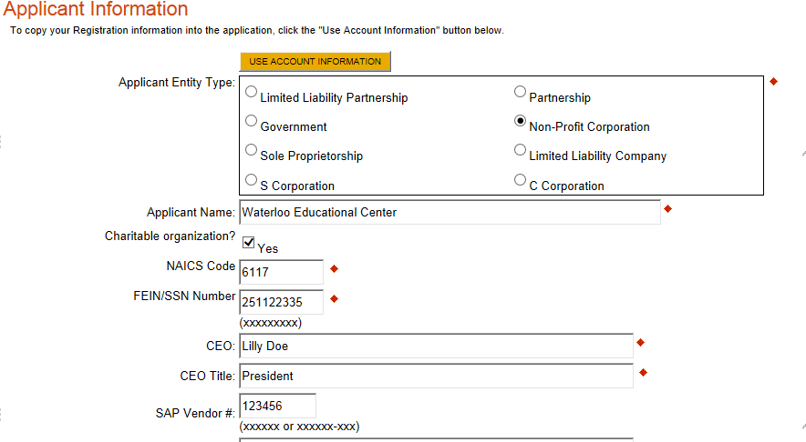

1. Indicate the application contact name or project director. This person will be contacted for budget information and program details. Indicate the name, title, including the director’s phone and fax numbers and email address and mailing address with organization’s name.

Check off the “Enterprise Type” that describes the organization’s work or “Other.”

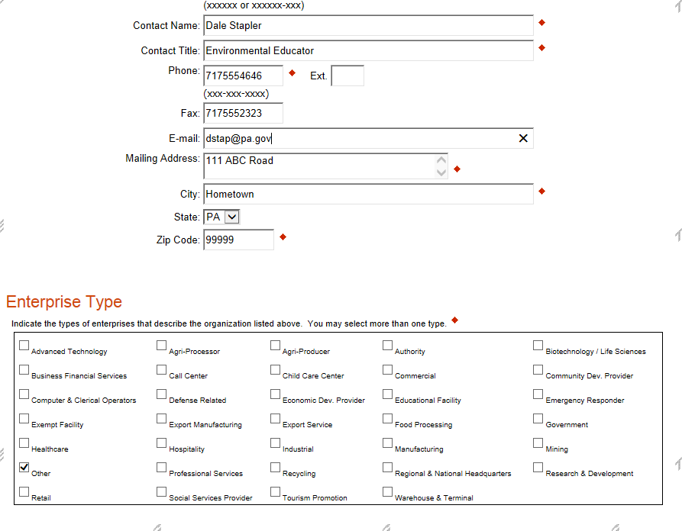

**Project Overview**

Complete all boxes in this section.

1. Project Name – Fill in the title of the project. The project name may edited for any incomplete application.
2. Is this project related to another previously submitted project? Select yes or no. If yes, explain.
3. If you have contacted DEP’s Environmental Education Grants Program, select yes and explain.
4. If you are you interested in submitting additional grant applications, select “yes.” While applicants are only permitted to apply for one project per application, by answering "yes", you will be given the ability to submit another application. Keep in mind, you do not need to apply for additional projects immediately. You are able to access any of your completed applications from the "Submitted Applications" link on the home page. If you wish to submit another application and you answered "No" to this question, please contact Customer Service by (800) 379-7448 8:30 a.m. - 5:00 p.m. EST Monday through Friday or [ra-dcedcs@state.pa.us](https://www.esa.dced.state.pa.us/ra-dcedcs@state.pa.us). Please have the Web Application ID readily available.

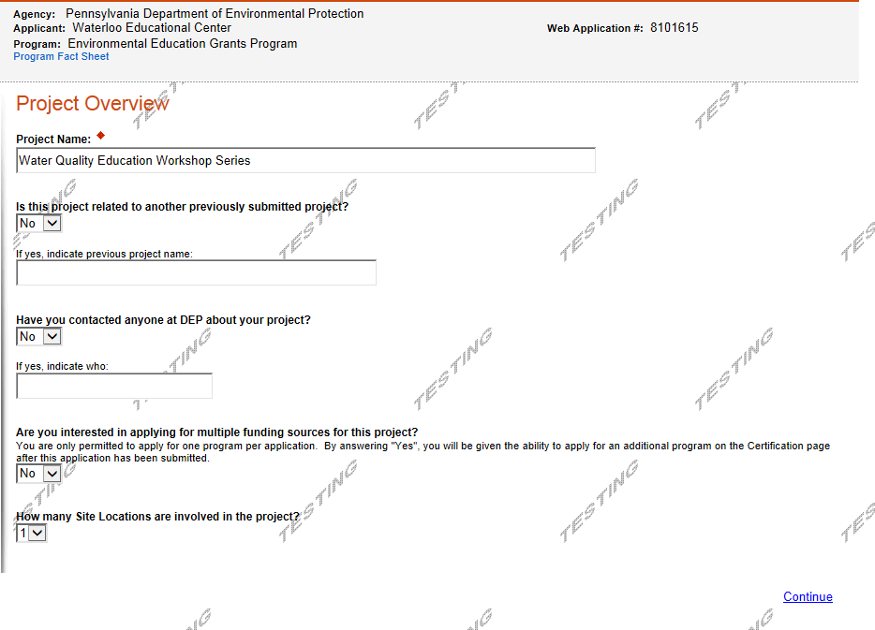

1. In some cases there may be at different site locations from the applying organization’s address. Indicate the number of actual project location, or site locations, for your project. This will control the number of project sites that appear in the application. If you wish to remove a specific Site Location from the project, you will still be able to remove a specific site in the Project Site section of the application.

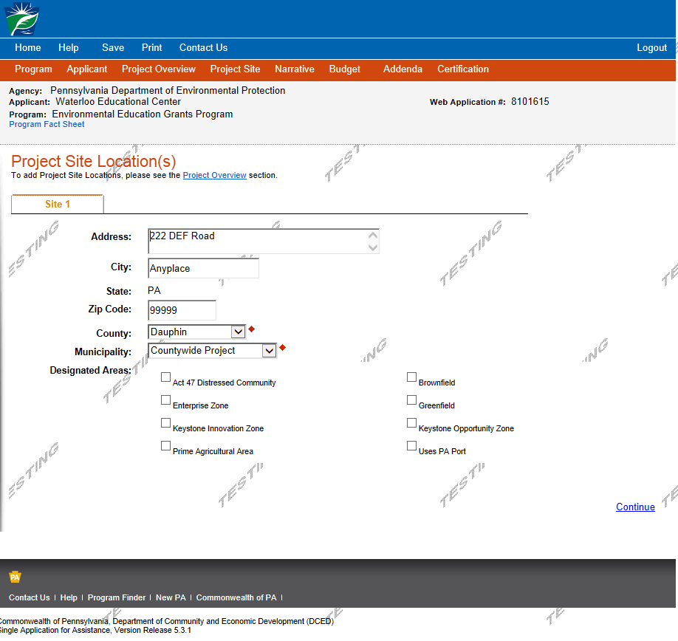

Project Narrative

In the first box, “What do you plan to accomplish with this project?” Fill in a concise, brief project description of no more than two sentences.

The other topics are prepopulated for other grant programs and do not need completed. In the Projected Schedule, Key Milestones and Dates, include a seasonal time line that is easy to follow with project steps with Activity Letters (A, B, C, etc.) that represent the activities to be accomplished.

Program Budget

Complete the Program Budget section. Insert matching funds with the funding sources tool and complete the basis of cost.

Program Addenda

1. Organization’s name and project director section

If the project is funded, the project director will coordinate the grant activities. This person will be contacted for budget information and program details. Indicate the official name of the organization. In some cases this may be a different organization. Indicate the project director, including the director’s phone and fax numbers and email address. Establish lines of communication within the organization about the grant. **Indicate the actual project location.**

If known, fill in your organization’s eFacts ID.

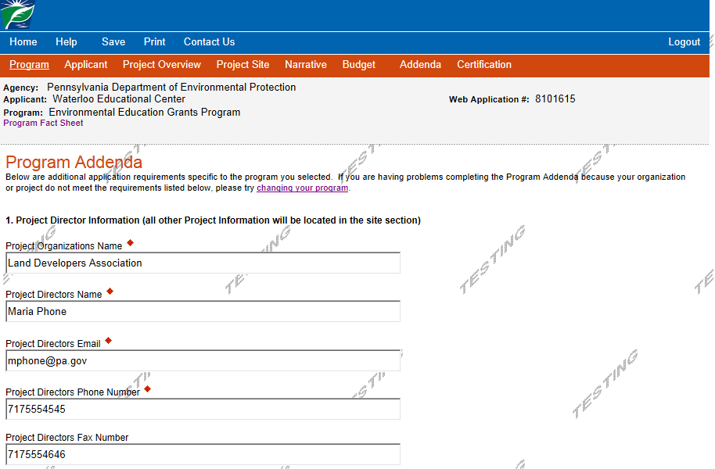

1. Topic area

Check off all topics that are the focus of proposal by selecting “yes” or “no.”

1. Project Focus

Check off the focus of the project, whether it is for the K-12 school community or a non-formal environmental education program, outside of the school setting, such as landowners, farmers, college students, 4-H clubs, etc.

1. Grant Track

Check off the grant track, whether it is a mini-grant application, for $3,000 or less, or a general grant, of up to $25,000. Note the grant’s timeframe.

1. River basin/Watershed Location

Indicate the watershed where your project is located. Find the watershed at <http://cfpub.epa.gov/surf/locate/index.cfm> .

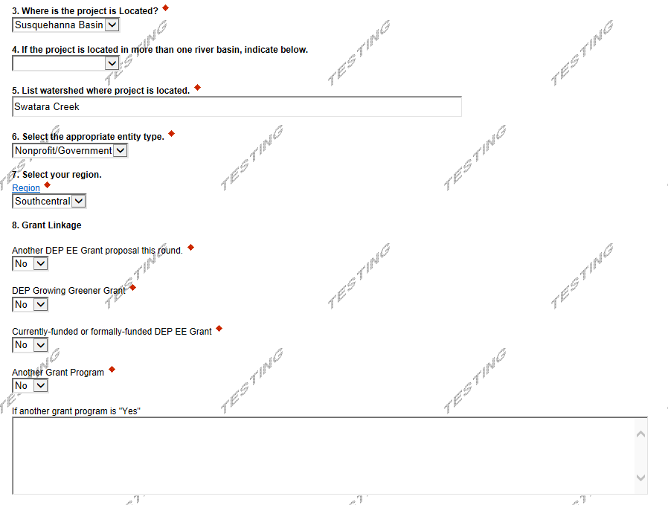

1. Entity Type

Use the drop down box to select the organization’s entity type.

1. Region

Use the drop down box to select the organization’s location within DEP’s regional offices. Click on the website link for assistance.

1. Grant Linkage

Is the application linked to another application or grant award if the scope of work is similar and integral to the same project? Is the application linked to another application from another organization? Is the proposal linked to any other DEP grant? If applications from the same organization are not linked at all, please state. Use the space provided to explain.

1. Indicate if the organization is submitting more than one proposal.

Multiple applications may be submitted from the same organization, but *each application must stand alone* – and be feasible – if awarded.

1. Budget Sheet, Narrative and Partnering Form

Download, complete and upload the detailed budget sheet, narrative and partnering forms. General grant applicants must submit the general grant detailed budget sheet. Mini-grant applicants must submit the mini-grant detailed budget sheet.

1. Budget Sheet

Fill in the line item totals for the grant, including People Costs, Travel Costs, Resource Costs and Other Costs. For matching funds, complete the matching funds source and amount. For all matching fund sources, a partnering form must be completed and submitted.

1. Application Certification

The person in charge of the daily operation of the workplace, i.e. school principal, executive director or conservation district director must sign the application. This signature attests that the organization is supportive of the proposal and that the grant funds will not supplant existing funds.

**Contact Us**

If you require assistance in completing the application, please contact DCED’s Customer Service.

|  |  |
| --- | --- |
| **Phone:** | (800) 379-7448 8:30 a.m. - 5:00 p.m. EST Monday through Friday |
| **Email:** | [ra-dcedcs@pa.gov](https://www.esa.dced.state.pa.us/ra-dcedcs@pa.gov) |

Narrative

The narrative should paint a clear picture of the proposed project. Be sure to address the following items in the narrative in **seven pages or less**:

Briefly describe the applying organization and its history of providing EE programming. If the applicant is a school district, private school or charter school, include a list or chart containing the number of individual schools in the district, the school names and the grade levels in each.

List the project steps or activities. Label each step or activity with **Activity Letters (A, B, C, etc. which will represent the activities that will be accomplished)**. Activity Letters also must be inserted on the project time line and budget sheet.

Identify the key people within the organization who will be completing the project. Describe their qualifications (no resumes) and duties.

Create a seasonal time line that is easy to follow, and briefly describe the activity (listing the applicable Activity Letter A, B, C, etc.).

Describe the specific goals and objectives. Remember, the goals focus on what the applicant intends to achieve. The objectives are the specific steps it will take to reach the goals.

List the project topics, Assessment Anchors and/or Academic Standards for Environment and Ecology; STEM (STEM standards only if the program is for children or youth).

Describe the project components focused on the “Project Options” section on page 5.

Detailed Budget Sheet

When completing the Detailed Budget Sheet, be sure that the following items are addressed.

All line-item details must be provided. Applicants must complete all of the columns for each line item‑quantity, unit costs, number of people, number of hours and activity letters.

Line items must be whole numbers (fifty cents or greater, round up to the nearest dollar; less than fifty cents, round down). Each line item must have mathematical integrity, including any matching funds.

Activity letters must correlate with the narrative and the amount spent on a specific task or item.

If more space is needed than the Detailed Budget Sheet provides, please use another copy of the form and indicate page 1 of 4, page 2 of 4, etc.

The EEGP staff has the right to negotiate or deny any line item during the grant contracting process.

Eligible Grant Expenditures

Please follow these category guidelines when completing the detailed budget sheet.

People Costs

Stipends for school teachers and administrators for work done outside the normal work day. Do not pro‑rate their salary for work done on this grant.

Staff time (number of hours).

Clerical support (number of hours).

Substitute teacher pay.

Travel Costs

Personal mileage at the current GSA rate. For more information, visit <http://www.gsa.gov/portal/content/100715> .

Transportation costs at a flat fee rate.

**Resource Costs**

Educational resources, such as: books, library/research resources, software, test kits, field guides, native plants and trees, mulch, shovels, hoes, garden trowels, gloves, building materials, signage, nets.

Equipment, such as: microscopes, binoculars, handheld GPS units, weather stations, structures and equipment, such as energy audit equipment.

Laboratory equipment (details are required): if more than $1,500 is proposed for equipment, include: where the item(s) will be located and how the item(s) will be used after proposed program ends.

Other Costs

Photocopying, printing, binding, graphic layout

Phone charges

Facility rental (other than awardee)

Advertising/marketing

Website

Postage costs

Ineligible Grant Expenditures

Food or beverages

Lodging or airfare

Computer hardware for general office use (i.e., laptops, iPADs/tablet computers)

* + No more than 10 percent of the entire grant can be used to purchase program-specific technology.

Staff salaries greater than 35 percent of the total amount of grant funds requested. Grant funds requested to pay staff benefits and contractual salary/benefits will be included in calculating this 35 percent cap.

Out of state travel

Award items (certificates, plaques)

Indirect costs, general operations or overhead charges: e.g. rent, utilities, monthly phone or website hosting charges

Boats, kayaks, paddle boards and canoes (to purchase or rent)

Cameras, including go-pros.

Clothing (t-shirts, hats)

Lawn mowers and other power equipment

Furniture for general office use

Grants, scholarships or fellowships to be given by the grant recipient to a third party. Grant funds may be used to pay up to $100 a day for either substitute teachers or teacher stipends to enable teachers to participate in DEP EE grant-funded programs. Grant funds may also be used to provide classroom supplies to enable teachers to implement new programs, but not to provide cash payments to teachers for these supplies. Grant funds may not be used to pay for graduate credits that participants may earn at these events.

Pass-through of cash or incentive prizes to project participants, e.g. grant funds may not be used to provide services (such as septic system cleanouts) to project participants at a discounted cost.

Reimbursement for expenses prior to the effective start date.

Promotional items, such as stress balls, laser pointers, magnets, pins, etc.

Completing the Partnering Form

If an organization other than the applicant/grantee, supplies any of the matching funds or is responsible for assisting or completing some of the activities, this must be included on the partnering form. This includes subcontracting organizations.

Fill in the organization’s name and appropriate information for each partner.

Secure a signature from either the chief officer of this organization, or the signature of someone within the organization who can speak for the organization from a fiscal and/or programming perspective.

Explain what role this organization will play in the proposed program. Summarize the organization’s commitment.

If entering into a subcontract with this organization, please note.

If any of the resources that the grantee intends to purchase is going to be housed with this partner organization, this will need to be mentioned as well.

Submitting the Application

Applications must be submitted by 11:59 p.m. on January 11, 2019.

|  |
| --- |
| Award Requirements |

Applications must be submitted by 11:59 p.m. by January 11, 2019, to dep.pa.gov/EE_Grants. Mail, fax, email and late submissions will not be accepted.

Retain this manual and a copy of the application for future reference.

Awarded organizations will be notified on or about **April 22, 2019, in conjunction with Earth Day**. The EEGP reserves the right to make decisions about grant awards. DEP’s Grants Center will email instructions, Scope of Work Benchmarks and Budget, Detailed Budget Sheet and a DEP Grant Agreement (contract) to the individuals listed as the Chief Officer and Project Director on the Application cover page as soon as possible after that date. Please note that it takes approximately six weeks for the agreement to be fully executed after it is returned with the appropriate signatures. Advance payments are processed after the grant agreement is fully executed.

Since awarded projects may not begin work prior to **July 1, 2019**, it is possible that awarded organizations will not have an executed agreement until late summer of 2019. Work may begin without a fully executed agreement, but the grantee does so at its own risk. Please check the organization’s policy for beginning work without an executed agreement.

If awarded, grantees will receive a DEP Grant Agreement to be signed.

***Questions may be directed to***:

Department of Environmental Protection

EE Grants Program

EE Center, First Floor, RCSOB

P.O. Box 2063

Harrisburg, PA 17105-2063

Phone: (717) 705-3767

Fax: (717) 705-4093

Email: [gimyers@pa.gov](mailto:gimyers@pa.gov)

AT&T Relay Service for the Deaf: (800) 654-5984 (TDD)

[www.dep.pa.gov](http://www.dep.pa.gov), search: EE Grants

**0110-FM-EEIC0109 Rev. 10/2018**

**Pennsylvania Environmental Education**

**Grants Program 2019**

DEP Logo**MINI-GRANT DETAILED BUDGET SHEET**

|  |  |  |  |  |  |  |  |  |  |  |  |
| --- | --- | --- | --- | --- | --- | --- | --- | --- | --- | --- | --- |
| **Applying Organization Name** | | | | | | | **Project Director:** | | | | |
| **Budget Category** | | | | | | | | **Grant Request Amount** |  | **Matching**  **Funds**  **Amount** | **Matching Funds Source** |
| **PEOPLE COSTS** | **# of**  **People** | | **#**  **Hours** | | **Activity Letter** | | |
|  |  | |  | |  | | | $ |  | $ |  |
|  |  | |  | |  | | | $ |  | $ |  |
|  |  | |  | |  | | | $ |  | $ |  |
|  |  | |  | |  | | | $ |  | $ |  |
|  |  | |  | |  | | | $ |  | $ |  |
| **Subtotal** | | | | | | | | $ |  | $ |  |
| **TRAVEL COSTS (i.e., number of miles x standard mileage rate) Include Reason for Traveling.** | | | | | | **Activity Letter** | |  |  |  |  |
| 2 people x 5 x 30 x .56/mile | | | | | |  | |
| **Subtotal** | | | | | | | | **$** |  | **$** |  |
| **RESOURCE COSTS** | | **Units**  **(Qty.) #** | | **Unit**  **Cost** | | **Activity Letter** | |  |  |  |  |
|  | |  | |  | |  | | $ |  | $ |  |
|  | |  | |  | |  | | $ |  | $ |  |
|  | |  | |  | |  | | $ |  | $ |  |
|  | |  | |  | |  | | $ |  | $ |  |
|  | |  | |  | |  | | $ |  | $ |  |
|  | |  | |  | |  | | $ |  | $ |  |
|  | |  | |  | |  | | $ |  | $ |  |
| **Subtotal** | | | | | | | | $ |  | **$** |  |
| **OTHER COSTS** | | | | | | **Activity Letter** | |  |  |  |  |
|  | | | | | |  | | $ |  | **$** |  |
|  | | | | | |  | | $ |  | **$** |  |
|  | | | | | |  | | $ |  | **$** |  |
|  | | | | | |  | | $ |  | **$** |  |
| **Subtotal** | | | | | | | | **$** |  | **$** |  |
| **GRAND TOTAL** | | | | | | | | **$** |  | **$** |  |

**0110-FM-EEIC0109 Rev. 10/2018**

**Pennsylvania Environmental Education**

**Grants Program 2019**

DEP Logo**MINI-GRANT DETAILED BUDGET SHEET**

|  |  |  |  |  |  |  |  |  |  |  |  |
| --- | --- | --- | --- | --- | --- | --- | --- | --- | --- | --- | --- |
| **Applying Organization Name** | | | | | | | **Project Director:** | | | | |
| **Budget Category** | | | | | | | | **Grant Request Amount** |  | **Matching**  **Funds**  **Amount** | **Matching Funds Source** |
| **PEOPLE COSTS** | **# of**  **People** | | **#**  **Hours** | | **Activity Letter** | | |
|  |  | |  | |  | | | $ |  | $ |  |
|  |  | |  | |  | | | $ |  | $ |  |
|  |  | |  | |  | | | $ |  | $ |  |
|  |  | |  | |  | | | $ |  | $ |  |
|  |  | |  | |  | | | $ |  | $ |  |
| **Subtotal** | | | | | | | | $ |  | $ |  |
| **TRAVEL COSTS (i.e., number of miles x standard mileage rate) Include Reason for Traveling.** | | | | | | **Activity Letter** | |  |  |  |  |
| 2 people x 5 x 30 x .56/mile | | | | | |  | |
| **Subtotal** | | | | | | | | **$** |  | **$** |  |
| **RESOURCE COSTS** | | **Units**  **(Qty.) #** | | **Unit**  **Cost** | | **Activity Letter** | |  |  |  |  |
|  | |  | | 29.83 | |  | | $ 686 |  | $ |  |
|  | |  | |  | |  | | $ |  | $ |  |
|  | |  | |  | |  | | $ |  | $ |  |
|  | |  | |  | |  | | $ |  | $ |  |
|  | |  | |  | |  | | $ |  | $ |  |
|  | |  | |  | |  | | $ |  | $ |  |
|  | |  | |  | |  | | $ |  | $ |  |
| **Subtotal** | | | | | | | | $ |  | **$** |  |
| **OTHER COSTS** | | | | | | **Activity Letter** | |  |  |  |  |
|  | | | | | |  | | $ |  | **$** |  |
|  | | | | | |  | | $ |  | **$** |  |
|  | | | | | |  | | $ |  | **$** |  |
|  | | | | | |  | | $ |  | **$** |  |
| **Subtotal** | | | | | | | | **$** |  | **$** |  |
| **GRAND TOTAL** | | | | | | | | **$** |  | **$** |  |

**GENERAL GRANT DETAILED BUDGET SHEET**

**Note: All grant funding must be expended in the budgeted fiscal year to be eligible for reimbursement. Rolling over funds to the next fiscal year is not permitted.**

|  |  |  |  |  |  |  |  |
| --- | --- | --- | --- | --- | --- | --- | --- |
| **Applying Organization Name** | | | | **Project Director:** | | | |
| **Budget Category** | | | | **Grant Request Amount**  **7/1/19-6/30/20** |  | **Matching**  **Funds**  **Amount** | **Matching**  **Funds Source** |
| **PEOPLE COSTS** | **# of**  **People** | **#**  **Hours** | **Activity Letter** |
|  |  |  |  | $ |  | $ |  |
|  |  |  |  | $ |  | $ |  |
|  |  |  |  | $ |  | $ |  |
|  |  |  |  | $ |  | $ |  |
|  |  |  |  | $ |  | $ |  |
| **Subtotal** | | | | $ |  | $ |  |
| **TRAVEL COSTS (i.e., number of miles x standard mileage rate) Include Reason for Traveling.** | | | **Activity Letter** |  |  |  |  |
|  | | |  | $ |  | $ |  |
|  | | |  | $ |  | $ |  |
|  | | |  | $ |  | $ |  |
|  | | |  | $ |  | $ |  |
| **Subtotal** | | | | $ | $ | $ |  |
| **RESOURCE COSTS** | **Units**  **(Qty.) #** | **Unit**  **Cost** | **Activity Letter** |  |  |  |  | |
|  |  | $ |  | $ |  | $ |  | |
|  |  | $ |  | $ |  | $ |  | |
|  |  | $ |  | $ |  | $ |  | |
|  |  | $ |  | $ |  | $ |  | |
|  |  | $ |  | $ |  | $ |  | |
| **Subtotal** | | | | $ |  | $ |  |
| **OTHER COSTS** | | | **Activity Letter** |  |  |  |  |
|  | | |  | $ |  | $ |  |
|  | | |  | $ |  | $ |  |
|  | | |  | $ |  | $ |  |
| **Subtotal** | | | | $ |  | $ |  |
| **GRAND TOTAL** | | | | $ |  | $ |  |

**GENERAL GRANT DETAILED BUDGET SHEET**

**Note: All grant funding must be expended in the budgeted fiscal year to be eligible for reimbursement. Rolling over funds to the next fiscal year is not permitted.**

|  |  |  |  |  |  |  |  |
| --- | --- | --- | --- | --- | --- | --- | --- |
| **Applying Organization Name** | | | | **Project Director:** | | | |
| **Budget Category** | | | | **Grant Request Amount**  **7/1/19-6/30/20** |  | **Matching**  **Funds**  **Amount** | **Matching**  **Funds Source** |
| **PEOPLE COSTS** | **# of**  **People** | **#**  **Hours** | **Activity Letter** |
|  |  |  |  | $ |  | $ |  |
|  |  |  |  | $ |  | $ |  |
|  |  |  |  | $ |  | $ |  |
|  |  |  |  | $ |  | $ |  |
|  |  |  |  | $ |  | $ |  |
| **Subtotal** | | | | $ |  | $ |  |
| **TRAVEL COSTS (i.e., number of miles x standard mileage rate) Include Reason for Traveling.** | | | **Activity Letter** |  |  |  |  |
|  | | |  | $ |  | $ |  |
|  | | |  | $ |  | $ |  |
|  | | |  | $ |  | $ |  |
|  | | |  | $ |  | $ |  |
| **Subtotal** | | | | $ | $ | $ |  |
| **RESOURCE COSTS** | **Units**  **(Qty.) #** | **Unit**  **Cost** | **Activity Letter** |  |  |  |  | |
|  |  | $ |  | $ |  | $ |  | |
|  |  | $ |  | $ |  | $ |  | |
|  |  | $ |  | $ |  | $ |  | |
|  |  | $ |  | $ |  | $ |  | |
|  |  | $ |  | $ |  | $ |  | |
| **Subtotal** | | | | $ |  | $ |  |
| **OTHER COSTS** | | | **Activity Letter** |  |  |  |  |
|  | | |  | $ |  | $ |  |
|  | | |  | $ |  | $ |  |
|  | | |  | $ |  | $ |  |
| **Subtotal** | | | | $ |  | $ |  |
| **GRAND TOTAL** | | | | $ |  | $ |  |

**0110-FM-EEIC0107 Rev. 7/2016**

DEP Logo

**PARTNERING FORM**

***Each of the undersigned certifies agreement to lend support for this proposed environmental education program, if awarded.***

|  |  |
| --- | --- |
| **Applying Organization Name** | |
| **Partnering Organization(s)** | |
| Partner Name  Summary of Partner’s Commitment: | Telephone (   )  ***(Check Which is Applicable – can be both)***  Matching Funds Effort  Programming Assistance  Will there be a  Subcontract?  Yes  No  ***List Equipment or Resource Materials***  ***that will be housed with this Partner*** |
| Partner’s Signature Printed Name | |
| **Partnering Organization(s)** | |
| Partner Name  Summary of Partner’s Commitment: | Telephone (   )  ***(Check Which is Applicable – can be both)***  Matching Funds Effort  Programming Assistance  Will there be a  Subcontract?  Yes  No  ***List Equipment or Resource Materials***  ***that will be housed with this Partner*** |
| Partner’s Signature Printed Name | |
| ***Use a duplicate of this form if more than two partners will be involved.*** | |

**0110-FM-EEIC0107 Rev. 7/2016**

DEP Logo

**PARTNERING FORM**

***Each of the undersigned certifies agreement to lend support for this proposed environmental education program, if awarded.***

|  |  |
| --- | --- |
| **Applying Organization Name** | |
| **Partnering Organization(s)** | |
| Partner Name      .  Summary of Partner’s Commitment: | Telephone (   )  ***(Check Which is Applicable – can be both)***  Matching Funds Effort  Programming Assistance  Will there be a  Subcontract?  Yes  No  ***List Equipment or Resource Materials***  ***that will be housed with this Partner*** |
| Partner’s Signature Printed Name  *Nellie Loon* | |
| **Partnering Organization(s)** | |
| Partner Name  Summary of Partner’s Commitment: | Telephone (   )  ***(Check Which is Applicable – can be both)***  Matching Funds Effort  Programming Assistance  Will there be a  Subcontract?  Yes  No  ***List Equipment or Resource Materials***  ***that will be housed with this Partner*** |
| Partner’s Signature Printed Name | |
| ***Use a duplicate of this form if more than two partners will be involved.*** | |

**DEP Logo**

**MINI-GRANT FINAL REPORT Department of Environmental Protection**

**2019 Grant Round** Email: [kbanski@pa.gov](mailto:kbanski@pa.gov)

**Page 1 of 2** Phone: (717) 772-1857

Final Report – due July 15, 2020

**Organization Name ID Number Grant Document Number**

**Final Narrative** - Please report on **“benchmarks”** and/or **“deliverables”** items from the proposal and **grant agreement**. Submit any completed deliverables with this Final Report. Please use additional paper if necessary. Complete and accurate information, signature and date will be required in order to process your reimbursement request.

***Benchmarks and/or Deliverables*** (find as **Attachment D** of the **grant agreement**)

1.

2.

3.

4.

5.

6.

7.

**MINI-GRANT FINAL REPORT**

**2019 Grant Round**

**Page 2 of 2**

**Organization Name ID Number Grant Document Number**

Are you requesting a reimbursement of grant funds?  Yes  No

If yes, how much? $

Were you able to complete all the project activities by the end of the contract?

Yes  No - If no, please provide an explanation.

|  |
| --- |
|  |

Signature of Project Director or Authorized Official Date

___________________________________________

Printed Name of Project Director or Authorized Official

**DEP Logo**

**GENERAL GRANT PROGRESS REPORT Department of Environmental Protection**

**2019 Grant Round** Email: [kbanski@pa.gov](mailto:kbanski@pa.gov)

**Page 1 of 2** Phone: (717) 772-1857

Progress Report – due January 15, 2020

**Organization Name EE Number Grant Document Number**

**Final Narrative** - Please report on **“benchmarks”** and/or **“deliverables”** items from the proposal and **grant agreement**. Submit any completed deliverables with this Final Report. Please use additional paper if necessary. Complete and accurate information, signature and date will be required in order to process your reimbursement request.

***Benchmarks and/or Deliverables*** (find as **Attachment D** of the **grant agreement**)

1.

2.

3.

4.

5.

6.

7.

**GENERAL GRANT PROGRESS REPORT**

**2019 Grant Round**

**Page 2 of 2**

**Organization Name ID Number Grant Document Number**

Are you requesting a reimbursement of grant funds?  Yes  No

If yes, how much? $

Were you able to complete all the project activities by the end of the contract?

Yes  No - If no, please provide an explanation.

|  |
| --- |
|  |

Signature of Project Director or Authorized Official Date

___________________________________________

Printed Name of Project Director or Authorized Official

**DEP Logo**

**GENERAL GRANT FINAL REPORT Department of Environmental Protection**

**2019 Grant Round** Email: [kbanski@pa.gov](mailto:kbanski@pa.gov)

Phone: (717) 772-1857

**Page 1 of 2**

**Final Report – due July 15, 2020**

**Organization Name ID Number Grant Document Number**

**Final Narrative** - Please report on **“benchmarks”** and/or **“deliverables”** items from the proposal and **grant agreement**. Submit any completed deliverables with this Final Report. Please use additional paper if necessary. Complete and accurate information, signature and date will be required in order to process your reimbursement request.

***Benchmarks and/or Deliverables*** (find as **Attachment D** of the **grant agreement**)

1.

2.

3.

4.

5.

6.

7.

**GENERAL GRANT FINAL REPORT**

**2019 Grant Round**

**Page 2 of 2**

**Organization Name ID Number Grant Document Number**

Are you requesting a reimbursement of grant funds?  Yes  No

If yes, how much? $

Were you able to complete all the project activities by the end of the contract?

Yes  No - If no, please provide an explanation.

|  |
| --- |
|  |

Signature of Project Director or Authorized Official Date

___________________________________________

Printed Name of Project Director or Authorized Official

|  |  |  |  |  |  |  |  |  |  |  |  |  |  |  |  |  |  |  |  |
| --- | --- | --- | --- | --- | --- | --- | --- | --- | --- | --- | --- | --- | --- | --- | --- | --- | --- | --- | --- |
| **DEP Logo0110-FM-EEIC0105 Rev. 2/2020** | | | **ENVIRONMENTAL EDUCATION GRANTS PROGRAM**  **EXPENSE REIMBURSEMENT REQUEST FORM**  **- SUMMARY PAGE -** | | | | | | | | | | | | | Invoice Date:  Invoice No:  Invoice Amount:  SUBMIT FORM TO:  Environmental Education Grants Program  PA Dept. of Environmental Protection  Email:RA-epEEgrants@pa.gov | | | |
|  | | |  | | | | | | | | | | | | |
| **Grant Recipient Name** |  | | | | | | | | | | | | | | |
| (Administering Organization) |  | | | | | | | | | | | | | | |
| **SAP Contract Agreement # (C99XXXXXXXX)** | | | |  | | | | | | **Vendor #** | | | | | | | | | |
| **Contact Name** | |  | | | | | **Contact Email Address** | | | |  | | | | | | **Phone #** | |  |
| **Invoice Period-From** |  | | | | **To** |  | | | **Total Amount** | | | $ |  | | **Request #** | | |  | |
| **Partner Bank Type** |  | | | | | | |  | | | | | |  | | | | | |

|  |  |  |  |  |  |  |  |  |
| --- | --- | --- | --- | --- | --- | --- | --- | --- |
|  | **GRANT FUNDS** | | | | **APPLICANT MATCH** | | | |
|  | **Total Grant Amount** | **Total Reimbursed**  **to Date** | | **Reimbursement Request for this Period** | **Total Match Amount** | **Match Previously Expended** | | **Match Expended this Period** |
| **TOTAL** |  |  | |  |  |  | |  |
|  | | |  | | | |  | |
| Signature of Project Director or Authorized Official    Printed Name of Project Director or Authorized Official | | | Title | | | | Date | |

|  |  |  |  |  |  |  |  |  |  |  |
| --- | --- | --- | --- | --- | --- | --- | --- | --- | --- | --- |
| ***For Commonwealth Use Only*** | | | | | | | | | | |
| Approved by EE Grants Program: | | |  | |  |  | Approved by DEP Grant Center: |  | |  | |
| Date Approved: |  | | |  |  |  | Title: |  | |  | |
| Match Required: |  | % | | | |  | Date Approved: |  | |  | |
| JUSTIFICATION: To reimburse grantee for expenses, per DEP Grant Agreement, under the Environmental Education Grants Program. | | | | | | | | |  | |

**Invoices and receipts should not be sent with the Expense Reimbursement Request Form unless listed in the Scope of Work Benchmarks and Budget (Attachment D). They should be kept in your files as per the record retention policy.**

**0110-FM-EEIC0105 Rev. 2/2020**

|  |  |  |  |  |  |  |  |  |  |  |  |  |  |  |  |
| --- | --- | --- | --- | --- | --- | --- | --- | --- | --- | --- | --- | --- | --- | --- | --- |
| **ENVIRONMENTAL EDUCATION GRANTS PROGRAM**  **EXPENSE REIMBURSEMENT FORM - WORK PAGE 1** | | | | | | | | | | | | | | | |
| **Grant Recipient Name** |  | | | | **ID#** |  | **GR #** | |  | | **Request** **#** | | |  | |
|  |  | | | |  |  |  | | | | | | | |  |
| **PEOPLE COSTS** *(See notes box below)*  List personnel identified on the approved budget summary. (Use additional sheets if necessary.) | | | | | | | | | | | | | | | |
| **Name** | | **Role in the Program** | **Activity**  **Letter** | **Period of Payment** | **Total Time** | | | **Total Cost** | | **Matching Funds\*** | | | **Amount to be Reimbursed** | | |
| *Enter Mo-Day-Yr From-To* | *Enter Total Hours or Days Paid* | | | *Enter Rate x Hours or Rate x Days* | | *If Cash, Enter Amount* | | *If In-Kind, Enter Amount* |
|  | |  |  |  |  | | |  | |  | |  |  | | |
|  | |  |  |  |  | | |  | |  | |  |  | | |
|  | |  |  |  |  | | |  | |  | |  |  | | |
|  | |  |  |  |  | | |  | |  | |  |  | | |
|  | |  |  |  |  | | |  | |  | |  |  | | |
|  | |  |  |  |  | | |  | |  | |  |  | | |
|  | |  |  |  |  | | |  | |  | |  |  | | |
|  | |  |  |  |  | | |  | |  | |  |  | | |
|  | |  |  |  |  | | |  | |  | |  |  | | |
|  | |  |  |  |  | | |  | |  | |  |  | | |
| *If someone outside your organization is paid a flat fee, include a check number and date paid.* | | | | **Total People Costs:** | | | | **$** | | **$** | | **$** | **$** | | |
| **\*Notes for “Matching Funds” Columns** | | | | | | | | | | | | | | | |
| 1. If “Cash” or “In-Kind” is entered, deduct these amounts from “Total Cost” and enter the balance in the “Amount to be Reimbursed” column. 2. Appropriate documentation for all costs and matching funds or activities must be retained in your files. | | | | | | | | | | | | | | | |

All columns must be completed to receive reimbursement.

**0110-FM-EEIC0105 Rev. 2/2020**

|  |  |  |  |  |  |  |  |
| --- | --- | --- | --- | --- | --- | --- | --- |
| **ENVIRONMENTAL EDUCATION GRANTS PROGRAM**  **EXPENSE REIMBURSEMENT FORM - WORK PAGE 2** | | | | | | | |
| **Grant Recipient Name** |  | **ID#** |  | **GR #** |  | **Request** # |  |
|  | | | | | | | |

|  |  |  |  |  |  |  |  |  |  |
| --- | --- | --- | --- | --- | --- | --- | --- | --- | --- |
| **RESOURCE COSTS** | | | | | | | | | |
| **Materials/Supplies** | **Activity Letter** | **Unit Cost** | **Quantity Acquired** | **Total Cost** | **Matching Funds** | | **Amount  to be Reimbursed** | **Vendor Name** | **Check No. and Date Paid (if paid with credit card, enter “credit” with date paid)** |
| ***Name of Item*** | *Enter Unit Cost X Quantity Acq.* | *If Cash, Enter Amount* | *If In-Kind,*  *Enter Value* |
|  |  |  |  |  |  |  |  |  |  |
|  |  |  |  |  |  |  |  |  |  |
|  |  |  |  |  |  |  |  |  |  |
|  |  |  |  |  |  |  |  |  |  |
|  |  |  |  |  |  |  |  |  |  |
|  |  |  |  |  |  |  |  |  |  |
|  |  |  |  |  |  |  |  |  |  |
|  |  |  |  |  |  |  |  |  |  |
|  |  |  |  |  |  |  |  |  |  |
|  |  |  |  |  |  |  |  |  |  |
|  |  |  |  |  |  |  |  |  |  |
|  |  |  |  |  |  |  |  |  |  |
|  |  |  |  |  |  |  |  |  |  |
|  |  |  |  |  |  |  |  |  |  |
|  |  |  |  |  |  |  |  |  |  |
|  |  |  |  |  |  |  |  |  |  |
| *If cash is paid by staff, include the check number and date used to reimburse.* | **Total Resource Cost** | | | **$** | **$** | **$** | **$** |  |  |

All columns must be completed to receive reimbursement.

**0110-FM-EEIC0105 Rev. 2/2020**

|  |  |  |  |  |  |  |  |  |  |  |  |  |  |  |  |  |  |
| --- | --- | --- | --- | --- | --- | --- | --- | --- | --- | --- | --- | --- | --- | --- | --- | --- | --- |
| **ENVIRONMENTAL EDUCATION GRANTS PROGRAM**  **EXPENSE REIMBURSEMENT FORM - WORK PAGE 3** | | | | | | | | | | | | | | | | | |
| **Grant Recipient Name** | |  | | | | | | **ID#** |  | | **GR #** | |  | | **Request** # | |  |
|  | | | | | | | | | | | | | | | | | |
| **TRAVEL COSTS** | | | | | | | | | | | | | | | | | |
| **Name**  ***(Project Staff Person***  ***or Carrier)*** | **Activity Letter** | | **Dates Cost Incurred**  *(List Separately by Mo-Day-Yr)* | | **Carrier Cost**  *(Flat fee, per trip fee, etc.)* | **Personal Vehicles**  **(State’s mileage rate during invoice period)** | | | | **Total Cost**  *(Enter Rate x Mileage)* | | **Matching Funds** | | | | **Amount**  **to be**  **Reimbursed** | | |
| *If Cash, Enter Amount* | | *If In-Kind, Enter Value* | |
|  |  | |  | |  |  | | | |  | |  | |  | |  | | |
|  |  | |  | |  |  | | | |  | |  | |  | |  | | |
|  |  | |  | |  |  | | | |  | |  | |  | |  | | |
|  |  | |  | |  |  | | | |  | |  | |  | |  | | |
|  |  | |  | |  |  | | | |  | |  | |  | |  | | |
| **Total Travel Cost:** | | | | | | **$** | | | | **$** | | **$** | | **$** | | **$** | | |
|  |  | | |  |  | | | | |  | |  | |  | |  | | |
|  |  | | |  |  | |  | | |  | |  | |  | |  | | |
| **OTHER COSTS** | | | | | | | | | | | | | | | | | | |
| **Item** | **Activity Letter** | | | **Unit Cost** | **Quantity Acquired** | | **Total Cost** | | | **Matching Funds** | | **Amount to be Reimbursed** | | **Vendor Name** | | **Check No. and Date Paid (if paid with credit card, enter “credit” with date paid)** | | |
|  |  | | |  |  | |  | | |  | |  | |  | |  | | |
|  |  | | |  |  | |  | | |  | |  | |  | |  | | |
|  |  | | |  |  | |  | | |  | |  | |  | |  | | |
|  |  | | |  |  | |  | | |  | |  | |  | |  | | |
|  |  | | |  |  | |  | | |  | |  | |  | |  | | |
| **Total Other Costs:** | | | | | | | **$** | | | **$** | | **$** | |  | |  | | |